
Perth Modern School
Semester One Examination, 2011

Question/Answer Booklet

Student Name SOLUTIONS

Teachers Name ______________________

Year _______________________________

MATHEMATICS
3A/3B
Section One:
Calculator-free

Student Number: In figures

In words

Time allowed for this section
Reading time before commencing work: 5 minutes
Working time for this section: 50 minutes

Material required/recommended for this section

To be provided by the supervisor
This Question/Answer Booklet
Formula Sheet

To be provided by the candidate
Standard items: pens, pencils, pencil sharpener, eraser, correction fluid, ruler, highlighters

Important note to candidates
No other items may be taken into the examination room. It is your responsibility to ensure that you do not have any unauthorised notes or other items of a non-personal nature in the examination room. If you have any unauthorised material with you, hand it to the supervisor before reading any further.

Structure of this paper

Section | Number of questions available | Number of questions to be answered | Working time (minutes) | Marks  available
Section One:  Calculator-free | 10 | 10 | 50 | 40
Section Two  Calculator-assumed | 14 | 14 | 100 | 80
 |  |  |  | 120

Instructions to candidates

1. The rules for the conduct of Western Australian external examinations are detailed in the Year 12 Information Handbook 2010. Sitting this examination implies that you agree to abide by these rules.

2. Write your answers in the spaces provided in this Question/Answer Booklet. Spare pages are included at the end of this booklet. They can be used for planning your responses and/or as additional space if required to continue an answer.
  - Planning: If you use the spare pages for planning, indicate this clearly at the top of the page.
  - Continuing an answer: If you need to use the space to continue an answer, indicate in the original answer space where the answer is continued, i.e. give the page number. Fill in the number of the question(s) that you are continuing to answer at the top of the page.

3. Show all your working clearly. Your working should be in sufficient detail to allow your answers to be checked readily and for marks to be awarded for reasoning. Incorrect answers given without supporting reasoning cannot be allocated any marks. For any question or part question worth more than two marks, valid working or justification is required to receive full marks. If you repeat an answer to any question, ensure that you cancel the answer you do not wish to have marked.

4. It is recommended that you do not use pencil except in diagrams.

Section One: Calculator-free (40 Marks)

Question 1 [1, 1, 1 marks]

Given the word CATS how many three letter ‘words’ can be formed which:

a) contain A? = 3 × 1 × 3 × 2 = 18 ✓

b) start with T? = 1 × 3 × 2 = 6 ✓

c) have A and C together? consider AC as one character
now we have 3 characters to fill 2 positions
= 3 × 2 × 2 = 12 ✓
AC/CA

Question 2 [2 marks]

Simplify the following expression.
Give your answer in exact form, as a base of 2.

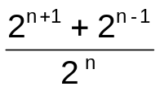
= 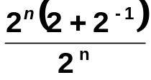✓
= 2+ ½ ✓

( If they give answer of 2.5 then accept)

Question 3 [1, 2, 2, marks]

Simplify the following expressing your answers with positive indices.

a) 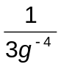 = 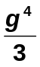 ✓

b) 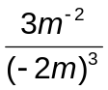 = 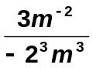 ✓ = 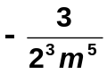 ✓ = 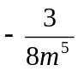

c) 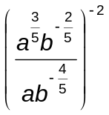 =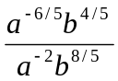✓
=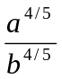✓
Question 4 [2 marks]
State the domain and range for the function 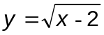.

domain x: x ≥ 2 ✓ range y: y ≥ 0 ✓

Question 5 [1, 1 marks]

For the function: 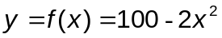, find:

a) 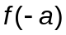 = 100 – 2a² ✓

b) 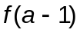 = 100 – 2(a – 1)² ✓

Question 6 [2, 3 marks]

Describe the sequence of transformations required to convert y = f(x) into y = g(x).

a) f(x) = x² and g(x) = (x – 2)² + 4
translate 2 units right ✓
then 4 units up ✓
- f(x) = x³ and g(x) = -(2x)³ + 4
translate 4 units up
dilate parallel to the x axis scale factor 0.5 ✓
then reflect about x axis ✓
translate 4 units up ✓

Question 7 [1, 1 marks]

Chèvre cheese is made of goats’ milk and is very expensive, costing $48.95 per kilogram. With the new government unit pricing policy, this price must be displayed in a $/100g format.

Convert the cheese price to

i) its unit price. = $48.95/kg
= $4.90/ 100g ✓

ii) a cost of cents / gram = $48.95/ 1000g
= 4895c / 1000 g
= 4.90c / g ✓

accept 5c / g

Question 8 [2, 1, 1 marks]

3000 people were surveyed to determine their favourite fruit from a choice of apples (A) and bananas (B). The people surveyed were asked to indicate their fruit preference as either apples, bananas, both or none of these. The company conducted the survey to determine the probability of future purchases of apples and bananas.

Their figures based on the survey showed that P() = 0.8, P(A) = 0.3 and P(B) = 0.7.

Draw a Venn diagram to represent this information.

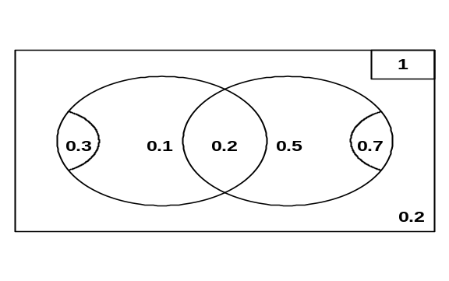
a) Hence or otherwise, find P(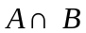). = 0.2 ✓

b) Find how many people indicated in the survey that they like both apples and bananas and could not choose between them.

n(like both apples and bananas & could not choose) = 0.2 × 3000
= 600 ✓

Question 9 [2, 3, 2 marks]

In each of the following solve for x.

a) 2^{3x – 2} = 2^{3x – 2} = 2⁶
3x – 2 = 6 ✓
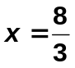✓

b) 9^{2 – x} = 27^{x} (3²)^{2-x} = (3³)^{x}
3^{4 - 2x} = 3^{3x} ✓
4 – 2x = 3x ✓
-5x = -4
x =  ✓

c) 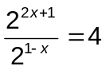 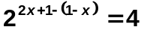
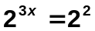✓
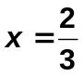 ✓
Question 10 [2, 6 marks]

a) For the set of scores 2, 5, 1, 3, 9, 10, 3, x

Find the value of x, if the

i) mean is 5 33 + x = 40
x = 7 ✓

ii) mode is 3. x ≠ 1, 2, 5, 9 or 10 ✓

b) Given the set of scores 10, 14, 8, 9, 11, 20, 16, 21, 36, 15

i) construct a box and whisker plot, clearly labelling the median, quartiles, minimum and maximum.
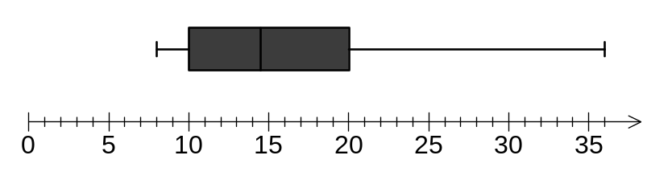

ii) calculate the interquartile range. = 20 -10 =10 ✓

iii) determine if any outliers exist, giving reason(s) for your decision. Outlier is 1.5 × IQR + UQ
= 1.5 × 10 + 20
= 35 ✓
Hence 36 is the outlier ✓

Spare Page
Spare Page

